ROLE BASED ACCESS CONTROLS : METHOD BY WHICH WE CAN GIVE RESTRICTED PERMISSION TO MY TEAM MEMBERS AS PER THERE ROLES IN THE COMPANY

TEAM : JOHN (DEVELOPER)
Adam (DEVELOPER)
AKSHAT (TESTER)
JAMES (ADMIN)

Now these people have different roles in the company and i want developer to have read and write access of the jobs whereas a tester should only have the read access of the job

So, i will use the concept of RBAC (role based access control) where i will create roles like developer , tester, admin
And assign the permission to these roles….
Now we can add users to these roles…for example i can add john , adam in developer role and akshat in tester and james in admin role

PRACTICALS:

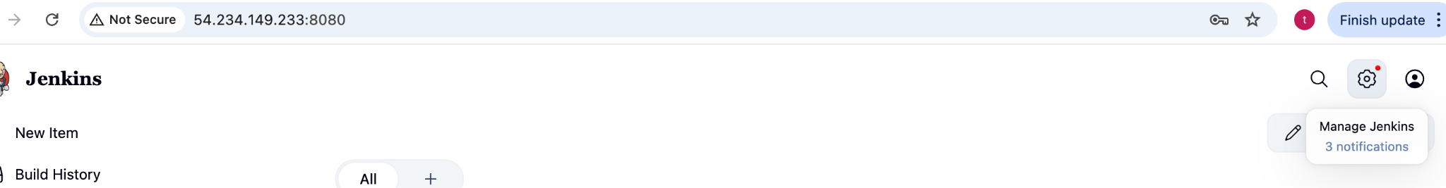

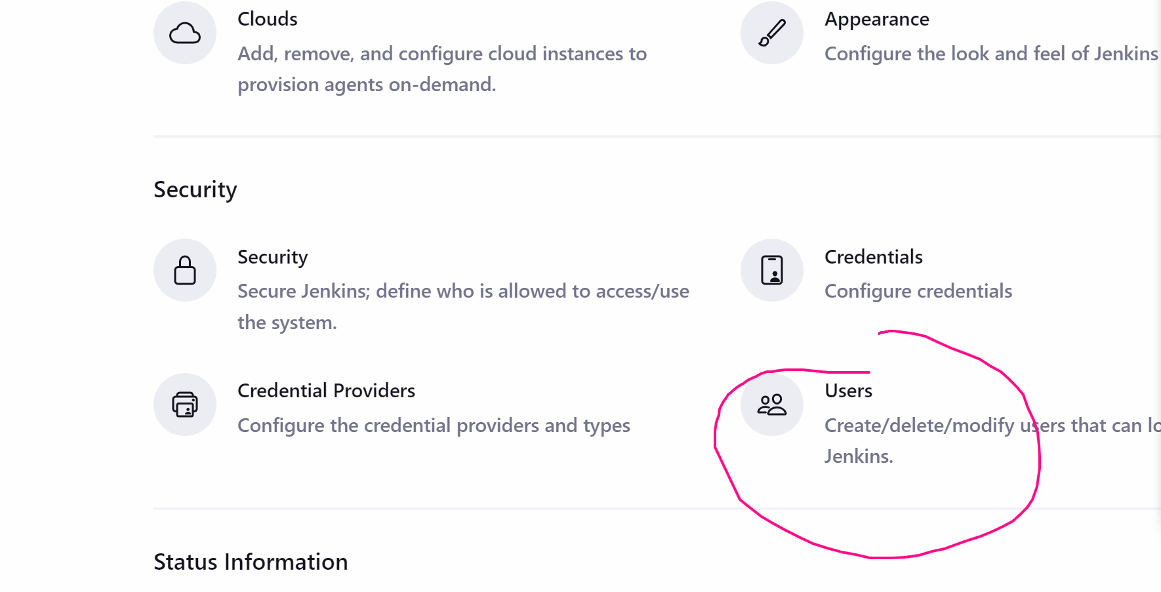

Create user
Create 2-3 users

Logout and login as those users you have created

They will have all the permission…it does not make any sense…we have to restrict the permissions

Logout and login as admin again

Manage jenkins -> plugins

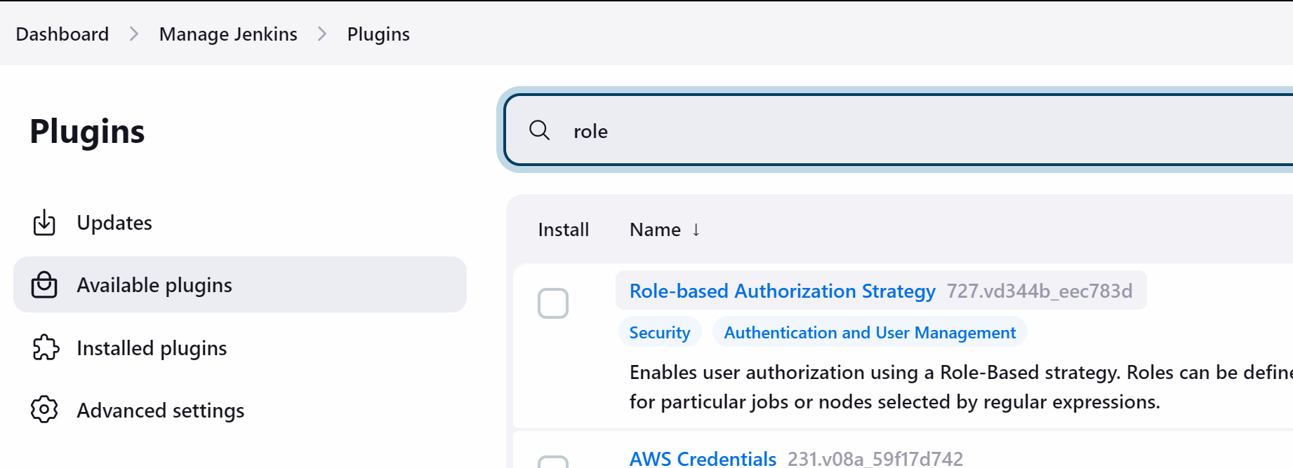

Install the plugin

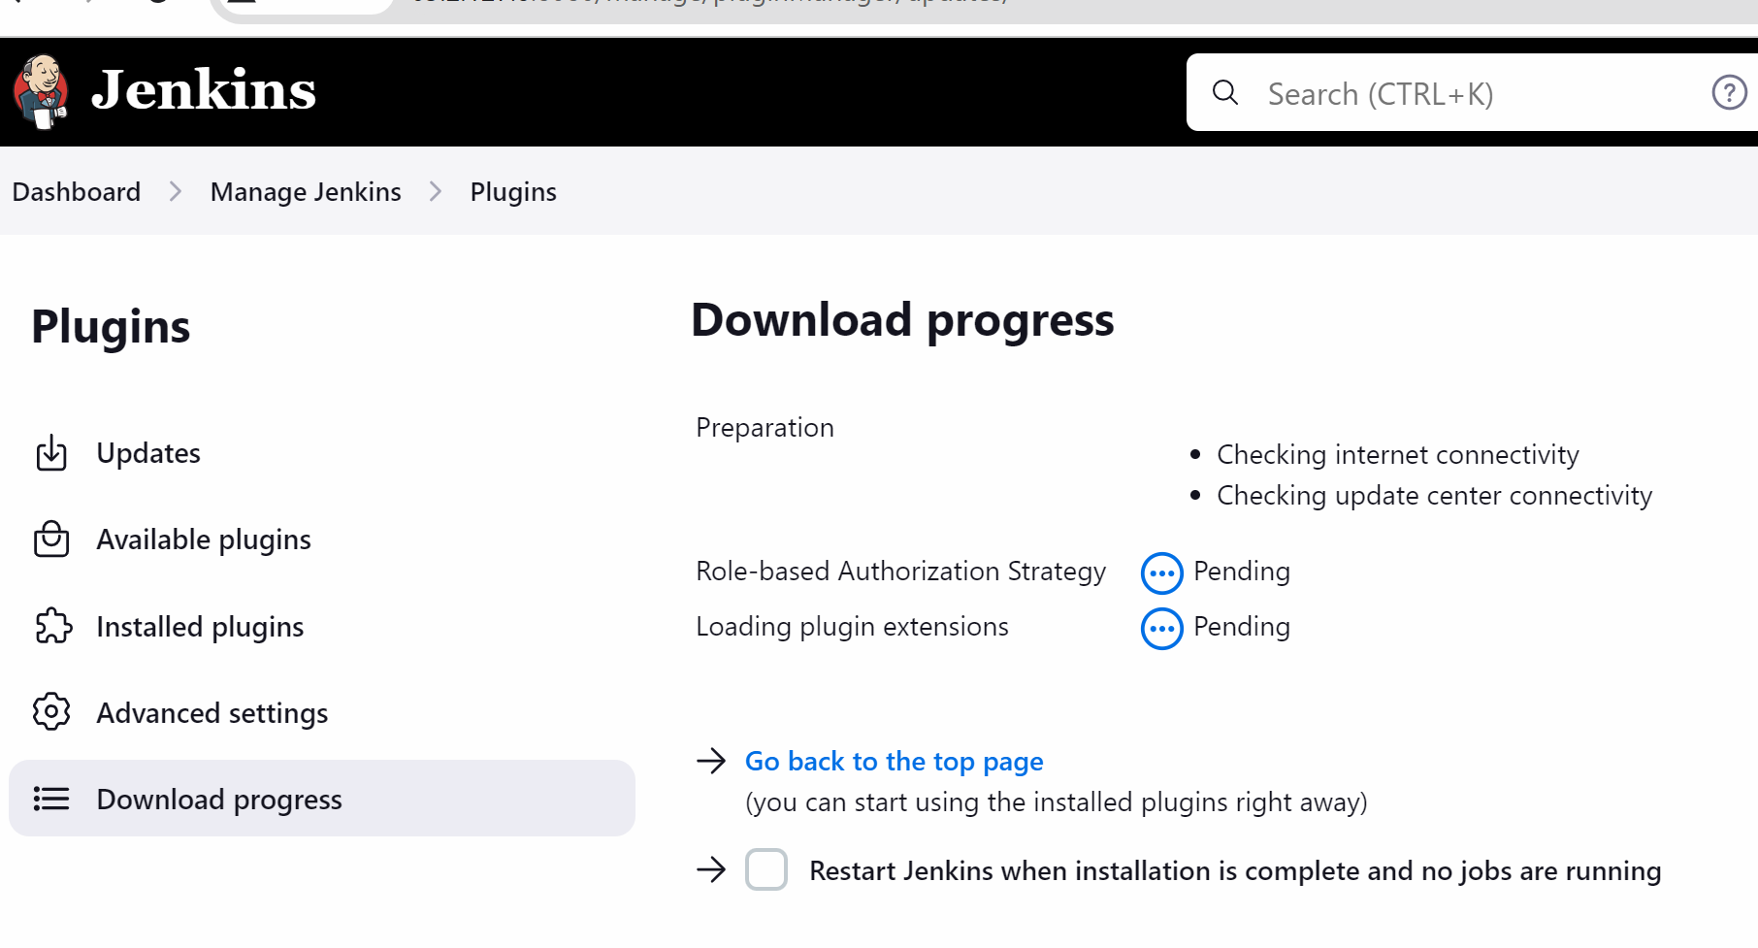

After this plugin is installed we will go to the manage jenkins -> security 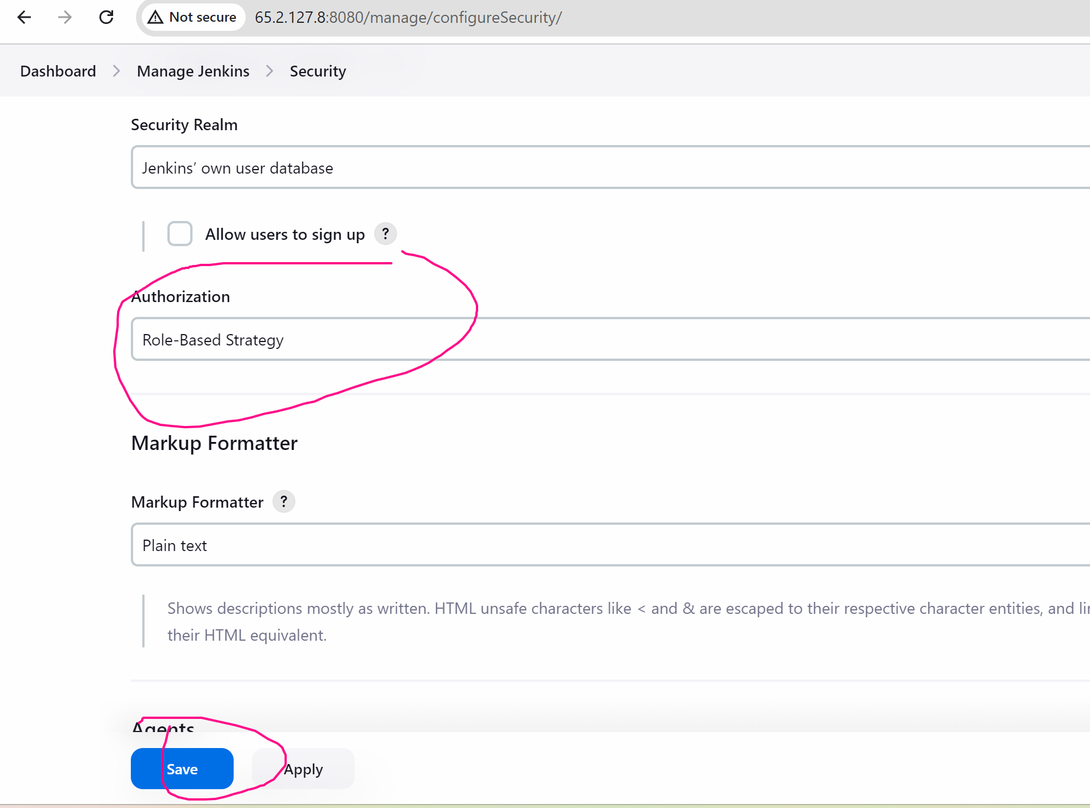 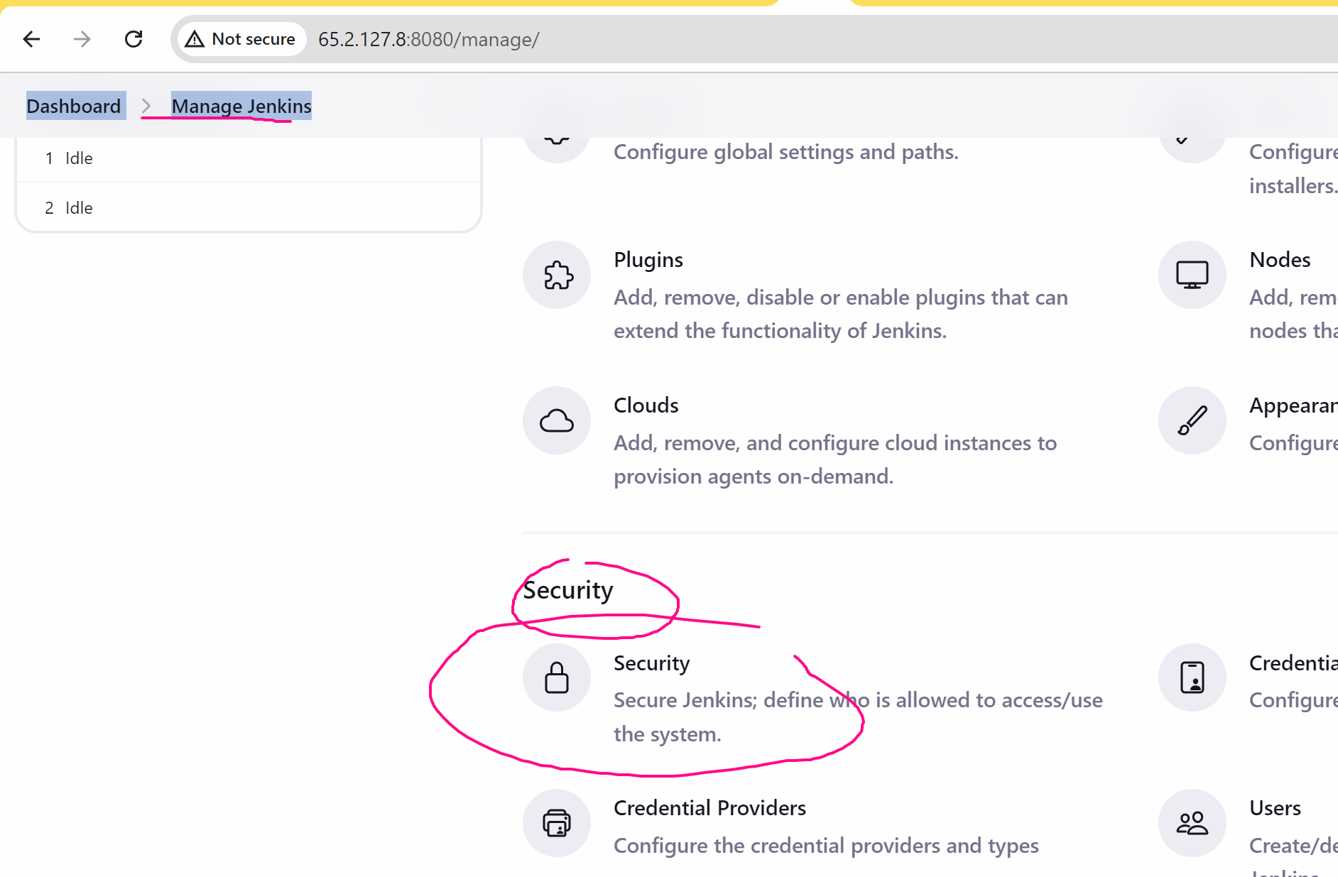



Lets logout and login as john user

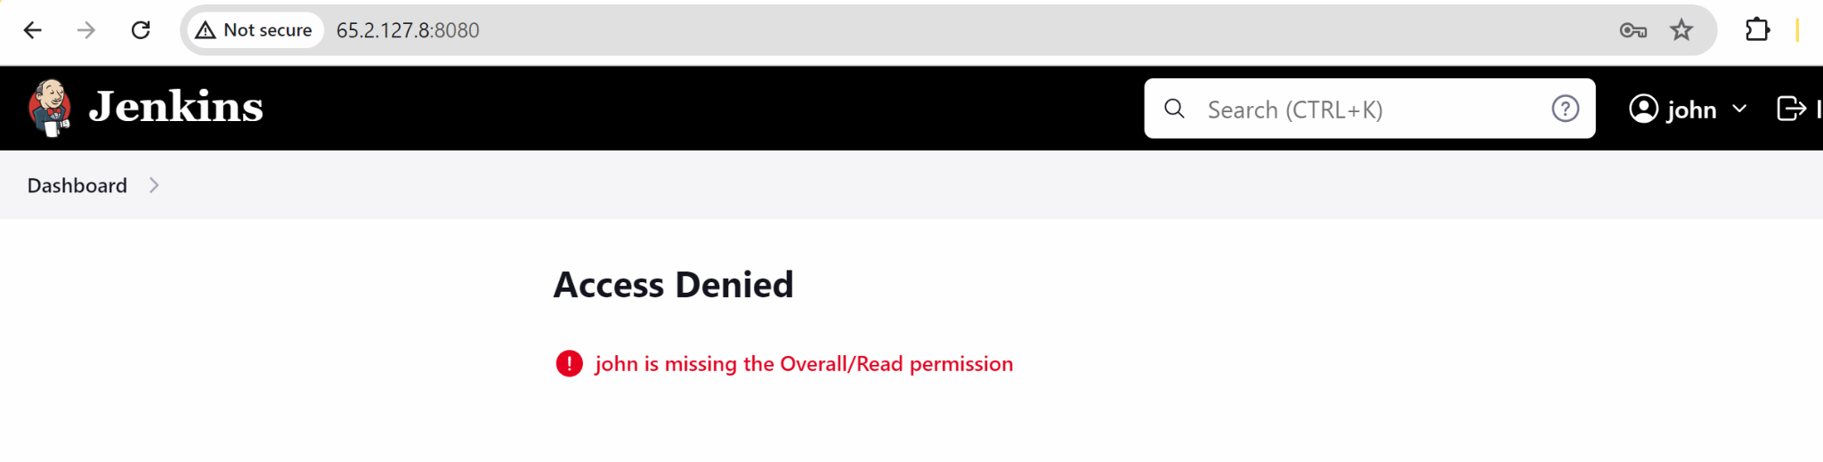

Logout

Now we will create a role and assign user to that role

Manage jenkins -> manage and assign role

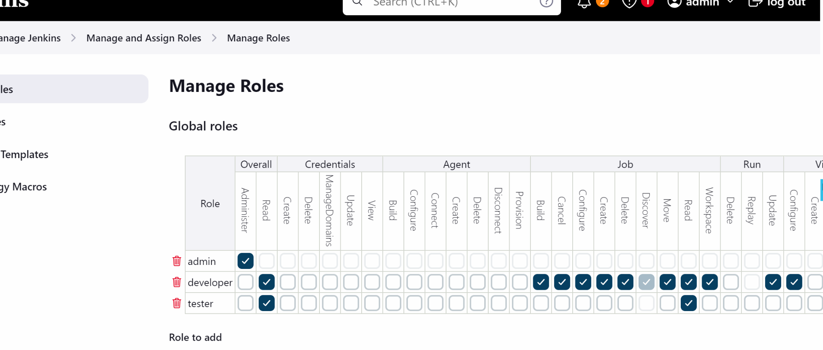

(develoepr have r/w access of jobs …..tester have read access of job)

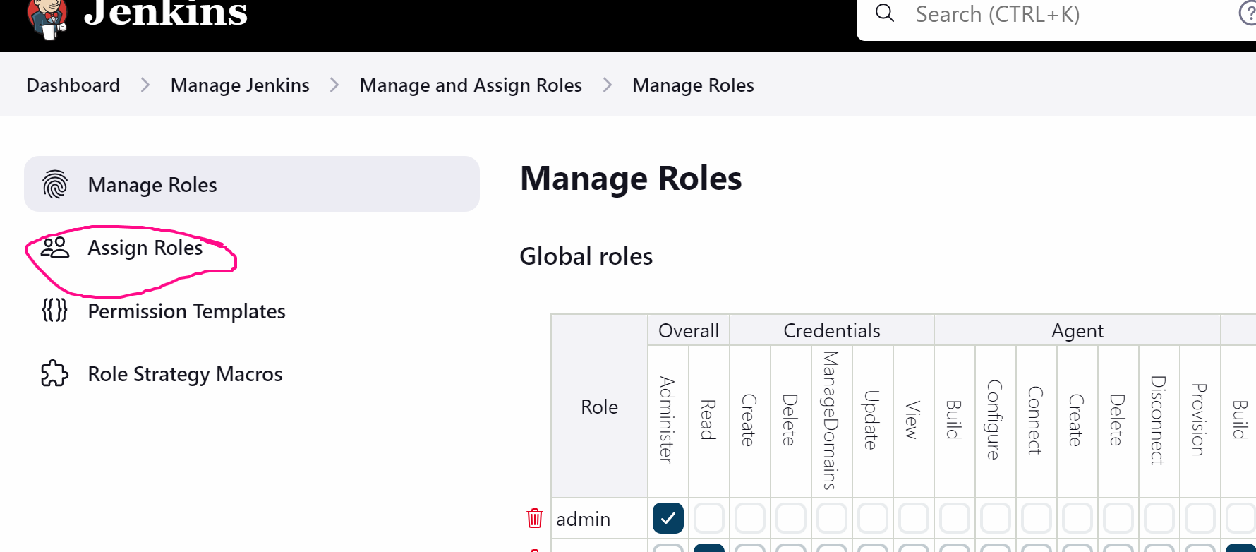

Add user
And add the user which you have created previously

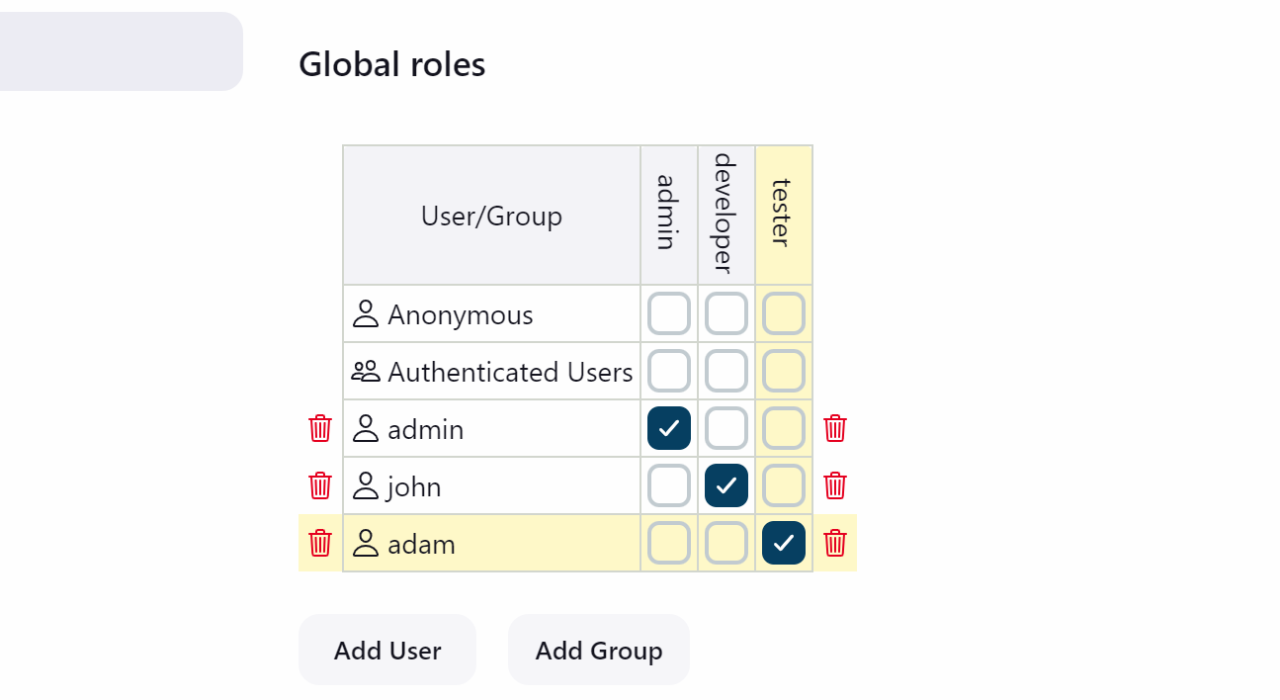

After saving logout and login as john user

You will seee the john can make changes to the job but does not have manage jenkins access
Whereas when you login adam user you will see that adam have only read access of the jobs and does not have access to manage jenkins

